Import Data dan Library

import pandas as pd import numpy as np

import matplotlib.pyplot as plt import seaborn as sns

from sklearn.model_selection import train_test_split

from sklearn.preprocessing import StandardScaler, MinMaxScaler from sklearn.linear_model import Ridge, Lasso

from sklearn.tree import DecisionTreeRegressor

from sklearn.ensemble import RandomForestRegressor

from sklearn.metrics import mean_squared_error, r2_score from sklearn.pipeline import Pipeline

from sklearn.feature_selection import SelectKBest, SelectPercentile, f_regression from sklearn.model_selection import GridSearchCV

from sklearn.metrics import mean_squared_error, mean_absolute_error, r2_score import time

Load Data

file_path = 'track_data_final.csv'

df_spotify = pd.read_csv(file_path) df_spotify.head()

**track_id track_name track_number track_popularity track_duration_ms explicit artist_name artist_popul**

**0** 6pymOcrCnMuCWdgGVTvUgP

3

57

61

213173

False

Britney Spears

**1** 2lWc1iJlz2NVcStV5fbtPG Clouds 1 67 158760 False BUNT.

**2** 1msEuwSBneBKpVCZQcFTsU

Forever & Always (Taylor’s Version)

11

63

225328

False Taylor Swift

**3**

7bcy34fBT2ap1L4bfPsl9q

I Didn't Change My

Number

2

72

158463

True Billie Eilish

**4** 0GLfodYacy3BJE7AI3A8en Man Down 7 57 267013 False Rihanna

print("Jumlah baris, kolom:", df_spotify.shape) print("\nTipe data:")

print(df_spotify.dtypes)

Jumlah baris, kolom: (8778, 15) Tipe data:

track_id object

track_name object

track_number int64

track_popularity int64

track_duration_ms int64

explicit bool

artist_name object artist_popularity float64 artist_followers float64

artist_genres object

album_id object

album_name object album_release_date object album_total_tracks int64

album_type object dtype: object

Pembersihan Data

Cek dan Menangani Missing Value

|  |  |
| --- | --- |
| track_id | 0 |
| track_name | 2 |
| track_number | 0 |
| track_popularity | 0 |
| track_duration_ms | 0 |
| explicit | 0 |
| artist_name | 4 |
| artist_popularity | 4 |
| artist_followers | 4 |
| artist_genres | 4 |
| album_id | 0 |
| album_name | 2 |
| album_release_date | 0 |
| album_total_tracks | 0 |
| album_type  dtype: int64 | 0 |

Cek dan Hapus Duplikat

# Cek ukuran awal

print("Dimensi awal:", df_spotify.shape)

# Cek missing value

print("\nMissing value per kolom:") print(df_spotify.isnull().sum())

Dimensi awal: (8778, 15) Missing value per kolom:

# Hapus kolom tidak relevan

cols_to_drop = [

'track_id', 'track_name', 'artist_name', 'artist_genres', 'album_id', 'album_name'

]

df_spotify = df_spotify.drop(columns=cols_to_drop) # Hapus baris dengan missing value

df_spotify = df_spotify.dropna()

print("\nDimensi setelah cleaning:", df_spotify.shape)

Dimensi setelah cleaning: (8774, 9)

Ubah ke Numerik

# Ubah Boolean (True/False) ke Angka (1/0)

df_spotify['explicit'] = df_spotify['explicit'].astype(int)

# Ambil tahun rilis dari tanggal

df_spotify['release_year'] = pd.to_datetime(

df_spotify['album_release_date'], errors='coerce'

).dt.year

# Hapus kolom tanggal asli

df_spotify = df_spotify.drop(columns=['album_release_date'])

# Drop NA hasil konversi tanggal df_spotify = df_spotify.dropna()

# One-Hot Encoding kolom kategorikal df_spotify = pd.get_dummies(

df_spotify,

columns=['album_type'], drop_first=True

)

print("\n=== DATA SIAP TRAINING ===")

print("Dimensi akhir:", df_spotify.shape) df_spotify.head()

|  |  |  |  |  |  |  |  |
| --- | --- | --- | --- | --- | --- | --- | --- |
| **track_number** | **track_popularity** | **track_duration_ms** | **explicit** | **artist_popularity** | **artist_followers** | **album_total_tracks** | **release** |
| **0** 57 | 61 | 213173 | 0 | 80.0 | 17755451.0 | 58 | 2 |
| **1** 1 | 67 | 158760 | 0 | 69.0 | 293734.0 | 1 | 2 |
| **2** 11 | 63 | 225328 | 0 | 100.0 | 145396321.0 | 26 | 2 |
| **3** 2 | 72 | 158463 | 1 | 90.0 | 118692183.0 | 16 | 2 |
| **4** 7 | 57 | 267013 | 0 | 90.0 | 68997177.0 | 13 | 2 |

Pemisahan Fitur Target dan Train Test Split

=== DATA SIAP TRAINING ===

Dimensi akhir: (8573, 10)

# Tentukan Fitur (X) dan Target (y) target = 'track_popularity'

X = df_spotify.drop(columns=[target]) y = df_spotify[target]

# Split Data (80:20) dengan Random State 28 # (Sesuai instruksi: 2 digit terakhir NPM)

X_train, X_test, y_train, y_test = train_test_split( X, y, test_size=0.2, random_state=28

)

print(f"Jumlah Data Training: {X_train.shape[0]}") print(f"Jumlah Data Testing : {X_test.shape[0]}")

Jumlah Data Training: 6858 Jumlah Data Testing : 1715

Standard Scaler

print("=== HASIL DENGAN STANDARD SCALER ===")

# 1. Scaling (Standardisasi) scaler_std = StandardScaler()

X_train_std = scaler_std.fit_transform(X_train) X_test_std = scaler_std.transform(X_test)

# 2. Model Ridge (L2 Regularization) ridge = Ridge(alpha=1.0)

ridge.fit(X_train_std, y_train)

y_pred_ridge = ridge.predict(X_test_std)

# 3. Model Lasso (L1 Regularization) lasso = Lasso(alpha=0.1)

lasso.fit(X_train_std, y_train)

y_pred_lasso = lasso.predict(X_test_std)

# Evaluasi

print(f"[Ridge] RMSE: {np.sqrt(mean_squared_error(y_test, y_pred_ridge)):.4f}, R2: {r2_score(y_test, y_pred_ridge):.4f}") print(f"[Lasso] RMSE: {np.sqrt(mean_squared_error(y_test, y_pred_lasso)):.4f}, R2: {r2_score(y_test, y_pred_lasso):.4f}")

=== HASIL DENGAN STANDARD SCALER === [Ridge] RMSE: 20.9049, R2: 0.2607

[Lasso] RMSE: 20.9038, R2: 0.2608

Minmax Scaler

print("=== HASIL DENGAN MINMAX SCALER ===")

# 1. Scaling (Normalisasi 0-1) scaler_mm = MinMaxScaler()

X_train_mm = scaler_mm.fit_transform(X_train) X_test_mm = scaler_mm.transform(X_test)

# 2. Model Ridge

ridge_mm = Ridge(alpha=1.0)

ridge_mm.fit(X_train_mm, y_train)

y_pred_ridge_mm = ridge_mm.predict(X_test_mm)

# 3. Model Lasso

lasso_mm = Lasso(alpha=0.1)

lasso_mm.fit(X_train_mm, y_train)

y_pred_lasso_mm = lasso_mm.predict(X_test_mm)

# Evaluasi

print(f"[Ridge] RMSE: {np.sqrt(mean_squared_error(y_test, y_pred_ridge_mm)):.4f}, R2: {r2_score(y_test, y_pred_ridge_mm):.4f}") print(f"[Lasso] RMSE: {np.sqrt(mean_squared_error(y_test, y_pred_lasso_mm)):.4f}, R2: {r2_score(y_test, y_pred_lasso_mm):.4f}")

=== HASIL DENGAN MINMAX SCALER === [Ridge] RMSE: 20.9040, R2: 0.2608

[Lasso] RMSE: 21.0106, R2: 0.2532

Pipeline Ridge Regression

print("=== PIPELINE RIDGE REGRESSION ===")

n_features = X_train.shape[1] # 1. Pipeline

pipe_ridge = Pipeline([

('scaler', MinMaxScaler()),

('feature_selection', SelectKBest(f_regression)), ('model', Ridge())

])

# 2. Parameter Grid param_grid_ridge = [

{

'feature_selection': [SelectKBest(f_regression)],

'feature_selection k': [5, n_features],

'model alpha': [0.1, 1.0]

},

{

'feature_selection': [SelectPercentile(f_regression)],

'feature_selection percentile': [25, 50],

'model alpha': [0.1, 1.0]

}

]

# 3. GridSearch

grid_ridge = GridSearchCV( pipe_ridge,

param_grid_ridge, cv=5,

scoring='r2'

)

grid_ridge.fit(X_train, y_train) # 4. Ambil model terbaik

best_ridge = grid_ridge.best_estimator_

# 5. Evaluasi

y_pred = best_ridge.predict(X_test)

print("Best Params:", grid_ridge.best_params_)

print("RMSE:", np.sqrt(mean_squared_error(y_test, y_pred))) print("R2:", r2_score(y_test, y_pred))

=== PIPELINE RIDGE REGRESSION ===

Best Params: {'feature_selection': SelectKBest(score_func=<function f_regression at 0x0000015655281B20>), 'feature_selection k' RMSE: 20.904765432473148

R2: 0.26074810535801785

Pipeline Lasso Regression

print("=== PIPELINE LASSO REGRESSION ===")

n_features = X_train.shape[1] # 1. Pipeline

pipe_lasso = Pipeline([

('scaler', MinMaxScaler()),

('feature_selection', SelectKBest(f_regression)), ('model', Lasso(max_iter=5000))

])

# 2. Parameter Grid param_grid_lasso = [

{

'feature_selection': [SelectKBest(f_regression)], 'feature_selection k': [5, n_features],

'model alpha': [0.01, 0.1, 1.0]

},

{

'feature_selection': [SelectPercentile(f_regression)], 'feature_selection percentile': [25, 50],

'model alpha': [0.01, 0.1, 1.0]

}

]

# 3. GridSearch

grid_lasso = GridSearchCV( pipe_lasso,

param_grid_lasso, cv=5,

scoring='r2'

)

grid_lasso.fit(X_train, y_train) # 4. Ambil model terbaik

best_lasso = grid_lasso.best_estimator_

# 5. Evaluasi

y_pred = best_lasso.predict(X_test)

print("Best Params:", grid_lasso.best_params_)

print("RMSE:", np.sqrt(mean_squared_error(y_test, y_pred))) print("R2:", r2_score(y_test, y_pred))

=== PIPELINE LASSO REGRESSION ===

Best Params: {'feature_selection': SelectKBest(score_func=<function f_regression at 0x0000015655281B20>), 'feature_selection k' RMSE: 20.903138907940157

R2: 0.2608631379393621

GridSearchCV

pipe_lasso = Pipeline([

('feature_selection', SelectKBest(score_func=f_regression)), ('model', Lasso(random_state=28, max_iter=5000))

])

from sklearn.feature_selection import SelectKBest, SelectPercentile, f_regression param_grid_lasso = [

# Lasso

{

'feature_selection': [None],

'model alpha': [0.001, 0.01, 0.1, 1.0, 10.0, 100.0]

},

# SelectKBest

{

'feature_selection': [SelectKBest(score_func=f_regression)], 'feature_selection k': [5, 10, 15, 20],

'model alpha': [0.01, 0.1, 1.0]

},

# SelectPercentile

{

'feature_selection': [SelectPercentile(score_func=f_regression)], 'feature_selection percentile': [25, 50, 75],

'model alpha': [0.01, 0.1, 1.0]

}

]

# Inisialisasi GridSearch

grid_lasso = GridSearchCV( estimator=pipe_lasso,

param_grid=param_grid_lasso,

cv=5,

scoring='r2', n_jobs=-1

# 5-fold cross-validation

# Gunakan R-squared untuk membandingkan model

# Menggunakan semua core CPU untuk komputasi paralel

)

print("Memulai proses fitting GridSearchCV...") start_time = time.time()

# Latih Grid Search pada data latih grid_lasso.fit(X_train, y_train)

end_time = time.time()

print(f"Proses fitting selesai dalam {end_time - start_time:.2f} detik.")

# --- HASIL DAN EVALUASI ---

best_lasso = grid_lasso.best_estimator_ y_pred = best_lasso.predict(X_test)

print("\n--- Hasil GridSearchCV dan Evaluasi Model Terbaik ---")

print(f"Best R2 Score (Cross-Validation): {grid_lasso.best_score_:.4f}") print("Best Params:", grid_lasso.best_params_)

# Hitung Metrik Evaluasi pada Test Set

mse = mean_squared_error(y_test, y_pred) rmse = np.sqrt(mse)

mae = mean_absolute_error(y_test, y_pred) r2 = r2_score(y_test, y_pred)

print(f"\nMean Squared Error (MSE) pada Test Set: {mse:.4f}")

print(f"Root Mean Squared Error (RMSE) pada Test Set: {rmse:.4f}") print(f"Mean Absolute Error (MAE) pada Test Set: {mae:.4f}")

print(f"R-squared (R2 Score) pada Test Set: {r2:.4f}")

Memulai proses fitting GridSearchCV...

Proses fitting selesai dalam 0.38 detik.

--- Hasil GridSearchCV dan Evaluasi Model Terbaik --- Best R2 Score (Cross-Validation): 0.2477

Best Params: {'feature_selection': None, 'model alpha': 0.001}

Mean Squared Error (MSE) pada Test Set: 437.0145

Root Mean Squared Error (RMSE) pada Test Set: 20.9049 Mean Absolute Error (MAE) pada Test Set: 15.8236

R-squared (R2 Score) pada Test Set: 0.2607

Scaflerplot Matrix

# Konversi X_train ke DataFrame dengan nama kolom asli X_train_df = pd.DataFrame(X_train, columns=X.columns)

# Pilih beberapa fitur penting untuk visualisasi (agar tidak terlalu padat) if X_train_df.shape[1] > 6:

# Gunakan korelasi untuk pilih fitur terpenting

corr_matrix = X_train_df.corrwith(pd.Series(y_train.values, index=X_train_df.index)).abs() top_features = corr_matrix.nlargest(6).index.tolist()

X_vis = X_train_df[top_features[:6]] else:

X_vis = X_train_df

# Tambahkan target untuk scatter matrix df_vis = X_vis.copy()

df_vis['target'] = y_train.values

print(f"Fitur: {list(X_vis.columns)}") # Buat scatter matrix

sns.pairplot(df_vis, diag_kind='kde', plot_kws={'alpha': 0.5})

plt.suptitle('Scatterplot Matrix: Hubungan Antar Fitur dan Target', y=1.02) plt.show()

Fitur: ['artist_popularity', 'artist_followers', 'album_type_single', 'explicit', 'album_type_compilation', 'track_duration_ms

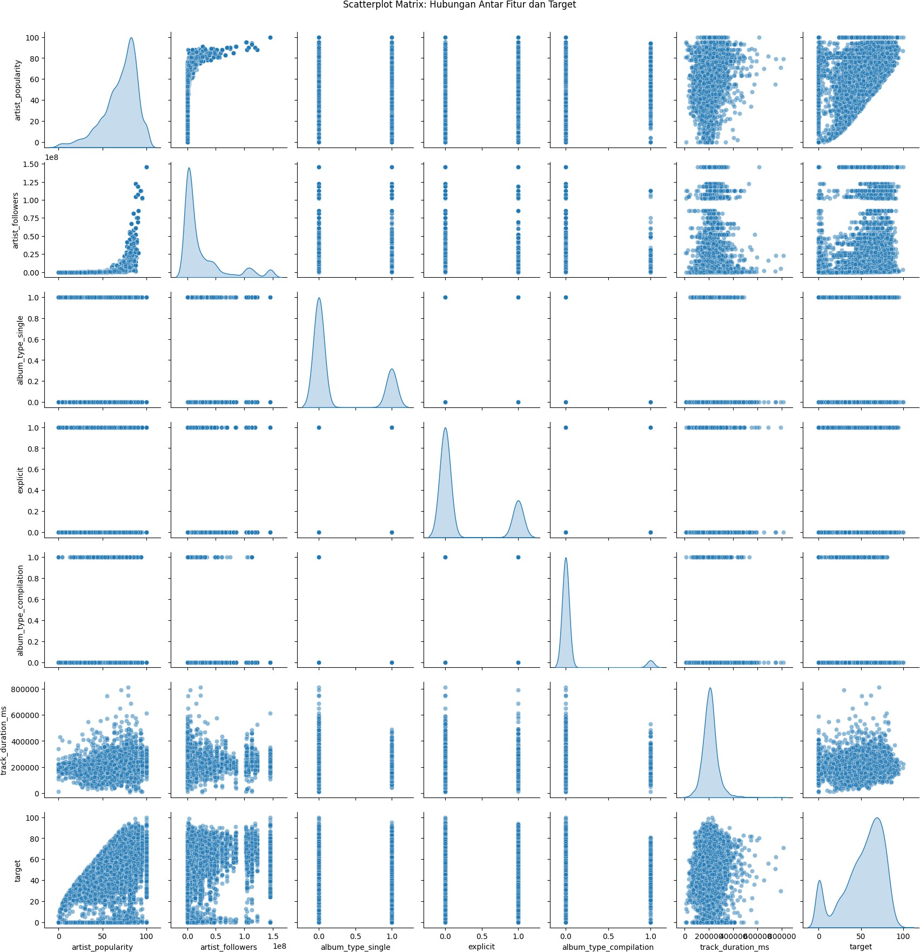

Plot Residual Training dan Test Data Untuk Setiap Model

models = {

'Ridge': best_ridge, 'Lasso': best_lasso

}

fig, axes = plt.subplots(2, 2, figsize=(14, 10)) axes = axes.flatten()

for idx, (name, model) in enumerate(models.items()): # Prediksi untuk training dan test

y_pred_train = model.predict(X_train) y_pred_test = model.predict(X_test)

# Residual

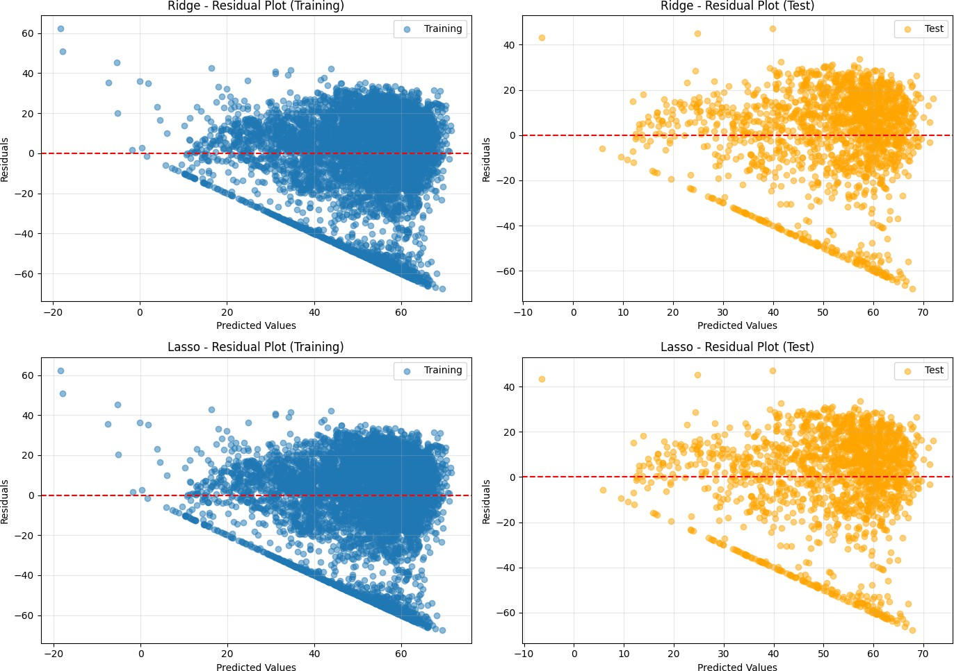

residuals_train = y_train - y_pred_train residuals_test = y_test - y_pred_test

# Plot residual training

axes[idx*2].scatter(y_pred_train, residuals_train, alpha=0.5, label='Training') axes[idx*2].axhline(y=0, color='r', linestyle='--')

axes[idx*2].set_xlabel('Predicted Values') axes[idx*2].set_ylabel('Residuals')

axes[idx*2].set_title(f'{name} - Residual Plot (Training)') axes[idx*2].legend()

axes[idx*2].grid(True, alpha=0.3)

# Plot residual test

axes[idx*2+1].scatter(y_pred_test, residuals_test, alpha=0.5, label='Test', color='orange') axes[idx*2+1].axhline(y=0, color='r', linestyle='--')

axes[idx*2+1].set_xlabel('Predicted Values') axes[idx*2+1].set_ylabel('Residuals')

axes[idx*2+1].set_title(f'{name} - Residual Plot (Test)') axes[idx*2+1].legend()

axes[idx*2+1].grid(True, alpha=0.3)

plt.tight_layout() plt.show()

Plot antara Fitur dan Target Untuk Setiap Model Pada Training Data

# Konversi X_train ke DataFrame

X_train_df = pd.DataFrame(X_train, columns=X.columns)

# Hitung korelasi dengan target

correlations = X_train_df.corrwith(pd.Series(y_train.values, index=X_train_df.index)).abs() top_4_features = correlations.nlargest(4).index.tolist()

print(f"4 fitur dengan korelasi tertinggi: {top_4_features}")

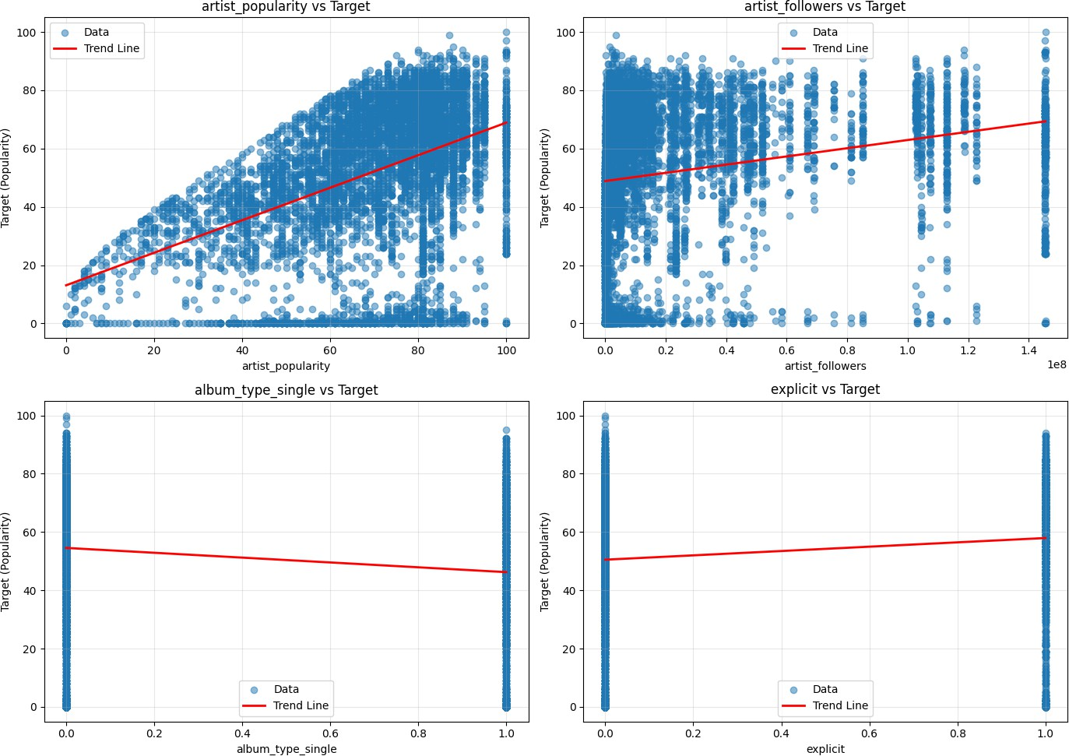

fig, axes = plt.subplots(2, 2, figsize=(14, 10)) axes = axes.flatten()

for i, feat_name in enumerate(top_4_features):

# Scatter plot - AKSES dengan NAMA kolom, bukan indeks

axes[i].scatter(X_train_df[feat_name], y_train, alpha=0.5, label='Data')

# Tambahkan garis regresi

x_vals = X_train_df[feat_name]

# Regresi linear sederhana

coeffs = np.polyfit(x_vals, y_train, 1) poly = np.poly1d(coeffs)

x_range = np.linspace(x_vals.min(), x_vals.max(), 100)

axes[i].plot(x_range, poly(x_range), color='red', linewidth=2, label='Trend Line')

axes[i].set_xlabel(feat_name)

axes[i].set_ylabel('Target (Popularity)') axes[i].set_title(f'{feat_name} vs Target') axes[i].legend()

axes[i].grid(True, alpha=0.3)

plt.tight_layout() plt.show()

4 fitur dengan korelasi tertinggi: ['artist_popularity', 'artist_followers', 'album_type_single', 'explicit']

Prediksi vs Aktual

fig, axes = plt.subplots(1, 2, figsize=(14, 6))

# Ambil 20 sampel pertama

sample_indices = range(min(20, len(X_test)))

for idx, (name, model) in enumerate(models.items()): # Prediksi untuk 20 sampel pertama

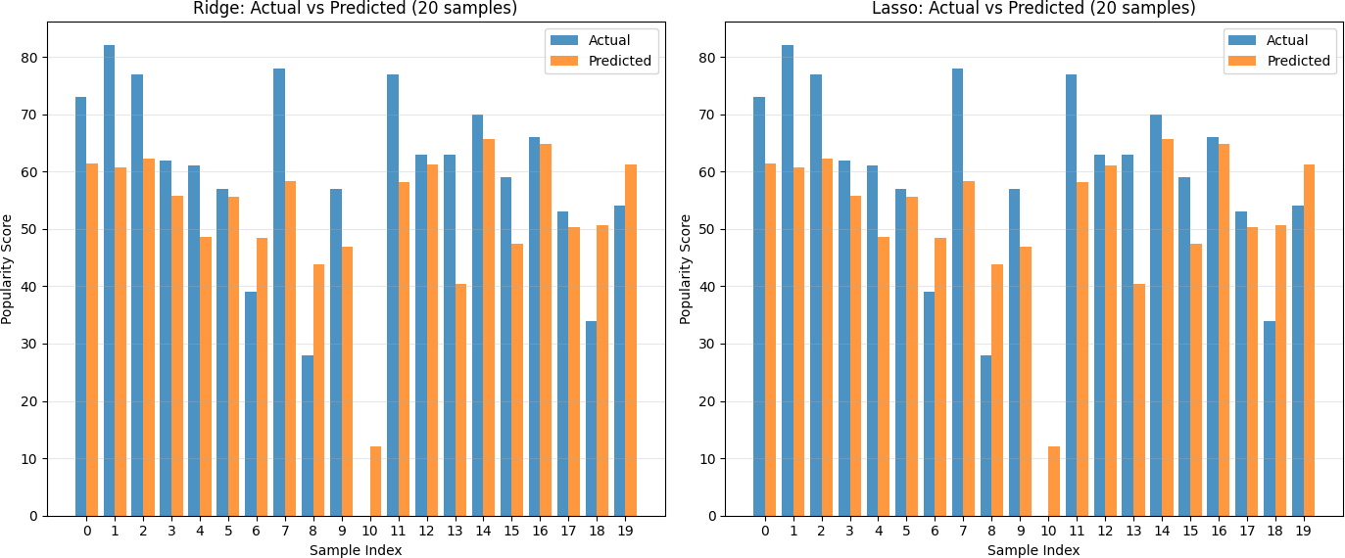

X_sample = X_test.iloc[sample_indices] if hasattr(X_test, 'iloc') else X_test[sample_indices]

y_true_sample = y_test.iloc[sample_indices] if hasattr(y_test, 'iloc') else y_test[sample_indices] y_pred_sample = model.predict(X_sample)

# Buat dataframe untuk plotting df_compare = pd.DataFrame({

'Actual': y_true_sample,

'Predicted': y_pred_sample,

'Sample': list(sample_indices)

})

# Plot bar chart

x_pos = np.arange(len(df_compare))

axes[idx].bar(x_pos - 0.2, df_compare['Actual'], width=0.4, label='Actual', alpha=0.8)

axes[idx].bar(x_pos + 0.2, df_compare['Predicted'], width=0.4, label='Predicted', alpha=0.8)

axes[idx].set_xlabel('Sample Index')

axes[idx].set_ylabel('Popularity Score')

axes[idx].set_title(f'{name}: Actual vs Predicted (20 samples)') axes[idx].set_xticks(x_pos)

axes[idx].legend()

axes[idx].grid(True, alpha=0.3, axis='y')

plt.tight_layout() plt.show()

Mengambil Model Terbaik

best_lasso_pipeline = grid_lasso.best_estimator_ best_params = grid_lasso.best_params_

best_cv_score = grid_lasso.best_score_

# Prediksi pada Test Set

y_pred_best = best_lasso_pipeline.predict(X_test)

# Hitung Metrik Evaluasi Akhir

mse = mean_squared_error(y_test, y_pred_best) rmse = np.sqrt(mse)

mae = mean_absolute_error(y_test, y_pred_best) r2 = r2_score(y_test, y_pred_best)

print(f"Algoritma: Lasso Regression (dalam Pipeline)") print(f"Parameter Terbaik: {best_params}")

print(f"R2 Score (Cross-Validation Terbaik): {best_cv_score:.4f}") print("-" * 50)

print("Metrik Evaluasi pada TEST SET:") print(f"R-squared (R2): {r2:.4f}")

print(f"Root Mean Squared Error (RMSE): {rmse:.4f}") print(f"Mean Squared Error (MSE): {mse:.4f}")

print(f"Mean Absolute Error (MAE): {mae:.4f}")

Algoritma: Lasso Regression (dalam Pipeline)

Parameter Terbaik: {'feature_selection': None, 'model alpha': 0.001} R2 Score (Cross-Validation Terbaik): 0.2477

Metrik Evaluasi pada TEST SET: R-squared (R2): 0.2607

Root Mean Squared Error (RMSE): 20.9049

Mean Squared Error (MSE): 437.0145 Mean Absolute Error (MAE): 15.8236

Export Pickle

import pickle

# Simpan model Lasso Regression yang sudah dilatih ke file .pkl (format biner) with open('notebook1_best_model.pkl', 'wb') as f:

pickle.dump(best_lasso_pipeline, f)

# Konfirmasi bahwa model berhasil disimpan

print(" Model Lasso Regression berhasil disimpan ke notebook1_best_model.pkl")

Model Lasso Regression berhasil disimpan ke notebook1_best_model.pkl

Import Data

import pandas as pd import numpy as np

import matplotlib.pyplot as plt import seaborn as sns

from sklearn.model_selection import train_test_split

from sklearn.preprocessing import StandardScaler, MinMaxScaler from sklearn.linear_model import Ridge, Lasso

from sklearn.tree import DecisionTreeRegressor

from sklearn.ensemble import RandomForestRegressor

from sklearn.metrics import mean_squared_error, mean_absolute_error, r2_score from sklearn.pipeline import Pipeline

from sklearn.feature_selection import SelectKBest, SelectPercentile, f_regression from sklearn.model_selection import GridSearchCV

import time

Load Data

file_path = 'track_data_final.csv'

df_spotify = pd.read_csv(file_path) df_spotify.head()

**track_id track_name track_number track_popularity track_duration_ms explicit artist_name artist_popul**

**0** 6pymOcrCnMuCWdgGVTvUgP

3

57

61

213173

False

Britney Spears

**1** 2lWc1iJlz2NVcStV5fbtPG Clouds 1 67 158760 False BUNT.

**2** 1msEuwSBneBKpVCZQcFTsU

Forever & Always (Taylor’s Version)

11

63

225328

False Taylor Swift

**3**

7bcy34fBT2ap1L4bfPsl9q

I Didn't Change My

Number

2

72

158463

True Billie Eilish

**4** 0GLfodYacy3BJE7AI3A8en Man Down 7 57 267013 False Rihanna

print("Jumlah baris, kolom:", df_spotify.shape) print("\nTipe data:")

print(df_spotify.dtypes)

Jumlah baris, kolom: (8778, 15) Tipe data:

track_id object

track_name object

track_number int64

track_popularity int64

track_duration_ms int64

explicit bool

artist_name object artist_popularity float64 artist_followers float64

artist_genres object

album_id object

album_name object album_release_date object album_total_tracks int64

album_type object dtype: object

Pembersihan Data

Cek dan Menangani Missing Value

|  |  |
| --- | --- |
| track_id | 0 |
| track_name | 2 |
| track_number | 0 |
| track_popularity | 0 |
| track_duration_ms | 0 |
| explicit | 0 |
| artist_name | 4 |
| artist_popularity | 4 |
| artist_followers | 4 |
| artist_genres | 4 |
| album_id | 0 |
| album_name | 2 |
| album_release_date | 0 |
| album_total_tracks | 0 |
| album_type  dtype: int64 | 0 |

Cek dan Hapus Duplikat

# Cek ukuran awal

print("Dimensi awal:", df_spotify.shape)

# Cek missing value

print("\nMissing value per kolom:") print(df_spotify.isnull().sum())

Dimensi awal: (8778, 15) Missing value per kolom:

# Hapus kolom tidak relevan

cols_to_drop = [

'track_id', 'track_name', 'artist_name', 'artist_genres', 'album_id', 'album_name'

]

df_spotify = df_spotify.drop(columns=cols_to_drop) # Hapus baris dengan missing value

df_spotify = df_spotify.dropna()

print("\nDimensi setelah cleaning:", df_spotify.shape)

Dimensi setelah cleaning: (8774, 9)

Ubah ke Numerik

# Ubah Boolean (True/False) ke Angka (1/0)

df_spotify['explicit'] = df_spotify['explicit'].astype(int)

# Ambil tahun rilis dari tanggal

df_spotify['release_year'] = pd.to_datetime(

df_spotify['album_release_date'], errors='coerce'

).dt.year

# Hapus kolom tanggal asli

df_spotify = df_spotify.drop(columns=['album_release_date'])

# Drop NA hasil konversi tanggal df_spotify = df_spotify.dropna()

# One-Hot Encoding kolom kategorikal df_spotify = pd.get_dummies(

df_spotify,

columns=['album_type'], drop_first=True

)

print("\n=== DATA SIAP TRAINING ===")

print("Dimensi akhir:", df_spotify.shape) df_spotify.head()

|  |  |  |  |  |  |  |  |
| --- | --- | --- | --- | --- | --- | --- | --- |
| **track_number** | **track_popularity** | **track_duration_ms** | **explicit** | **artist_popularity** | **artist_followers** | **album_total_tracks** | **release** |
| **0** 57 | 61 | 213173 | 0 | 80.0 | 17755451.0 | 58 | 2 |
| **1** 1 | 67 | 158760 | 0 | 69.0 | 293734.0 | 1 | 2 |
| **2** 11 | 63 | 225328 | 0 | 100.0 | 145396321.0 | 26 | 2 |
| **3** 2 | 72 | 158463 | 1 | 90.0 | 118692183.0 | 16 | 2 |
| **4** 7 | 57 | 267013 | 0 | 90.0 | 68997177.0 | 13 | 2 |

Pemisahan Fitur Target dan Train Test Split

=== DATA SIAP TRAINING ===

Dimensi akhir: (8573, 10)

# Tentukan Fitur (X) dan Target (y) target = 'track_popularity'

X = df_spotify.drop(columns=[target]) y = df_spotify[target]

# Split Data (80:20) dengan Random State 28 # (Sesuai instruksi: 2 digit terakhir NPM)

X_train, X_test, y_train, y_test = train_test_split( X, y, test_size=0.2, random_state=28

)

print(f"Jumlah Data Training: {X_train.shape[0]}") print(f"Jumlah Data Testing : {X_test.shape[0]}")

Jumlah Data Training: 6858 Jumlah Data Testing : 1715

Standard Scaler

print("=== HASIL DENGAN STANDARD SCALER ===")

# Scaling

scaler_std = StandardScaler()

X_train_std = scaler_std.fit_transform(X_train) X_test_std = scaler_std.transform(X_test)

# 1. Decision Tree (Rawan Overfitting)

dt = DecisionTreeRegressor(random_state=28) dt.fit(X_train_std, y_train)

y_pred_dt = dt.predict(X_test_std)

# 2. Random Forest (Ensemble - Lebih Stabil)

rf = RandomForestRegressor(n_estimators=100, random_state=28) rf.fit(X_train_std, y_train)

y_pred_rf = rf.predict(X_test_std)

# Evaluasi

print(f"[Decision Tree] RMSE: {np.sqrt(mean_squared_error(y_test, y_pred_dt)):.4f}, R2: {r2_score(y_test, y_pred_dt):.4f}") print(f"[Random Forest] RMSE: {np.sqrt(mean_squared_error(y_test, y_pred_rf)):.4f}, R2: {r2_score(y_test, y_pred_rf):.4f}")

=== HASIL DENGAN STANDARD SCALER ===

[Decision Tree] RMSE: 26.6669, R2: -0.2029

[Random Forest] RMSE: 20.0679, R2: 0.3188

Minmax Scaler

print("=== HASIL DENGAN MINMAX SCALER ===")

# Scaling

scaler_mm = MinMaxScaler()

X_train_mm = scaler_mm.fit_transform(X_train) X_test_mm = scaler_mm.transform(X_test)

# Decision Tree

dt_mm = DecisionTreeRegressor(random_state=28) dt_mm.fit(X_train_mm, y_train)

y_pred_dt_mm = dt_mm.predict(X_test_mm)

# Random Forest

rf_mm = RandomForestRegressor(n_estimators=100, random_state=28) rf_mm.fit(X_train_mm, y_train)

y_pred_rf_mm = rf_mm.predict(X_test_mm)

# Evaluasi

print(f"[Decision Tree] RMSE: {np.sqrt(mean_squared_error(y_test, y_pred_dt_mm)):.4f}, R2: {r2_score(y_test, y_pred_dt_mm):.4f} print(f"[Random Forest] RMSE: {np.sqrt(mean_squared_error(y_test, y_pred_rf_mm)):.4f}, R2: {r2_score(y_test, y_pred_rf_mm):.4f}

=== HASIL DENGAN MINMAX SCALER ===

[Decision Tree] RMSE: 26.8662, R2: -0.2210

[Random Forest] RMSE: 20.0647, R2: 0.3190

Visualisasi Fitur Penting

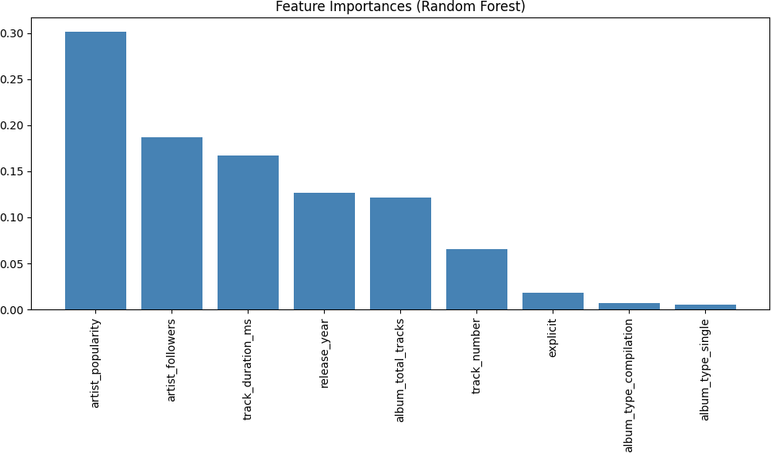

# Visualisasi Fitur Penting (Random Forest) importances = rf.feature_importances_

feature_names = X.columns

indices = np.argsort(importances)[::-1]

plt.figure(figsize=(10, 6))

plt.title("Feature Importances (Random Forest)")

plt.bar(range(X.shape[1]), importances[indices], align="center", color='steelblue') plt.xticks(range(X.shape[1]), feature_names[indices], rotation=90)

plt.tight_layout() plt.show()

Pipeline Decision Tree Regression

print("=== PIPELINE DECISION TREE REGRESSION ===")

n_features = X_train.shape[1] # 1. Pipeline

pipe_dt = Pipeline([

('scaler', MinMaxScaler()),

('feature_selection', SelectKBest(f_regression)), ('model', DecisionTreeRegressor(random_state=28))

])

# 2. Parameter Grid param_grid_dt = [

{

'feature_selection': [SelectKBest(f_regression)], 'feature_selection k': [5, n_features],

'model max_depth': [None, 5, 10]

},

{

'feature_selection': [SelectPercentile(f_regression)], 'feature_selection percentile': [25, 50],

'model max_depth': [None, 5, 10]

}

]

# 3. GridSearch

grid_dt = GridSearchCV( pipe_dt,

param_grid_dt, cv=5,

scoring='r2'

)

grid_dt.fit(X_train, y_train) # 4. Evaluasi

y_pred = grid_dt.best_estimator_.predict(X_test)

print("Best Params:", grid_dt.best_params_)

print("RMSE:", np.sqrt(mean_squared_error(y_test, y_pred))) print("R2:", r2_score(y_test, y_pred))

=== PIPELINE DECISION TREE REGRESSION ===

Best Params: {'feature_selection': SelectKBest(score_func=<function f_regression at 0x000001F4B6F61BC0>), 'feature_selection k' RMSE: 20.803718291242554

R2: 0.2678774610317086

Pipeline Random Forest Regression

print("=== PIPELINE RANDOM FOREST REGRESSION ===")

n_features = X_train.shape[1] # 1. Pipeline

pipe_rf = Pipeline([

('scaler', MinMaxScaler()),

('feature_selection', SelectKBest(f_regression)), ('model', RandomForestRegressor(random_state=28))

])

# 2. Parameter Grid param_grid_rf = [

{

'feature_selection': [SelectKBest(f_regression)], 'feature_selection k': [5, n_features],

'model n_estimators': [100], 'model max_depth': [None, 10]

},

{

'feature_selection': [SelectPercentile(f_regression)], 'feature_selection percentile': [25, 50],

'model n_estimators': [100], 'model max_depth': [None, 10]

}

]

# 3. GridSearch

grid_rf = GridSearchCV( pipe_rf,

param_grid_rf, cv=5,

scoring='r2', n_jobs=-1

)

grid_rf.fit(X_train, y_train)

# 4. Evaluasi

y_pred = grid_rf.best_estimator_.predict(X_test)

print("Best Params:", grid_rf.best_params_)

print("RMSE:", np.sqrt(mean_squared_error(y_test, y_pred))) print("R2:", r2_score(y_test, y_pred))

=== PIPELINE RANDOM FOREST REGRESSION ===

Best Params: {'feature_selection': SelectKBest(score_func=<function f_regression at 0x000001F4B6F61BC0>), 'feature_selection k' RMSE: 19.67199226438753

R2: 0.3453660288160846

Model Terbaik

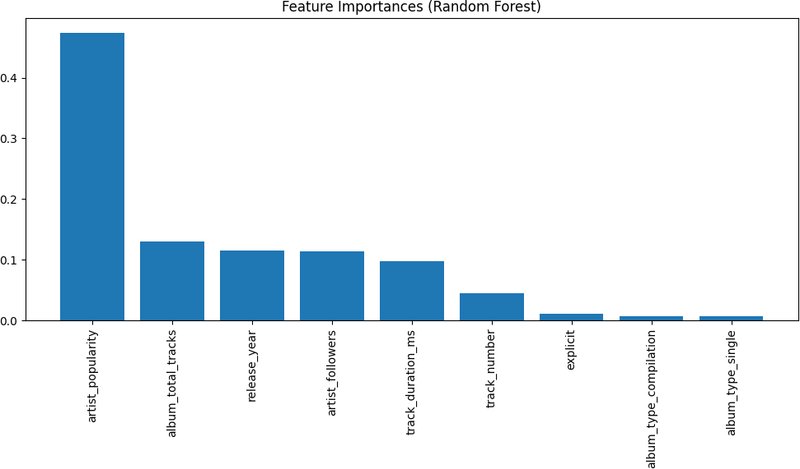

best_rf = grid_rf.best_estimator_.named_steps['model'] importances = best_rf.feature_importances_

feature_names = X.columns

indices = np.argsort(importances)[::-1] plt.figure(figsize=(10, 6))

plt.title("Feature Importances (Random Forest)")

plt.bar(range(len(importances)), importances[indices])

plt.xticks(range(len(importances)), feature_names[indices], rotation=90) plt.tight_layout()

plt.show()

GridSearchCV Random Forest

pipe_rf = Pipeline([

# 'feature_selection' adalah placeholder

('feature_selection', SelectKBest(score_func=f_regression)), # 'model' adalah Random Forest Regressor

('model', RandomForestRegressor(random_state=28))

])

param_grid_rf = [

# Kumpulan 1: Tanpa Feature Selection (Random Forest Saja)

{

'feature_selection': [None],

'model n_estimators': [50, 100, 200], # Coba jumlah estimator

'model max_depth': [5, 10, None], # Coba kedalaman maksimum

'model min_samples_split': [2, 5] # Coba min samples split

},

# Kumpulan 2: Dengan SelectKBest

{

'feature_selection': [SelectKBest(score_func=f_regression)],

'feature_selection k': [10, 20, 30], # Coba jumlah fitur terbaik (k) 'model n_estimators': [100],

'model max_depth': [10, 20],

}

]

grid_rf = GridSearchCV(

estimator=pipe_rf,

param_grid=param_grid_rf,

cv=5,

scoring='r2', n_jobs=-1

# Gunakan 5-fold cross-validation

# Gunakan R-squared untuk regresi # Menggunakan semua inti CPU

)

print("Memulai proses fitting GridSearchCV untuk Random Forest...") start_time = time.time()

# Latih Grid Search pada data latih grid_rf.fit(X_train, y_train)

end_time = time.time()

print(f"Proses fitting selesai dalam {end_time - start_time:.2f} detik.")

best_rf_pipeline = grid_rf.best_estimator_

y_pred_rf = best_rf_pipeline.predict(X_test)

print("\n--- Hasil Terbaik Random Forest ---")

print(f"Best R2 Score (Cross-Validation): {grid_rf.best_score_:.4f}") print("Best Params:", grid_rf.best_params_)

# Evaluasi Metrik pada Test Set

mse = mean_squared_error(y_test, y_pred_rf) rmse = np.sqrt(mse)

mae = mean_absolute_error(y_test, y_pred_rf) r2 = r2_score(y_test, y_pred_rf)

print(f"\nMean Squared Error (MSE) pada Test Set: {mse:.4f}")

print(f"Root Mean Squared Error (RMSE) pada Test Set: {rmse:.4f}") print(f"Mean Absolute Error (MAE) pada Test Set: {mae:.4f}")

print(f"R-squared (R2 Score) pada Test Set: {r2:.4f}")

Memulai proses fitting GridSearchCV untuk Random Forest... Proses fitting selesai dalam 70.05 detik.

--- Hasil Terbaik Random Forest ---

Best R2 Score (Cross-Validation): 0.3209

Best Params: {'feature_selection': None, 'model max_depth': 10, 'model min_samples_split': 5, 'model n_estimators': 200}

Mean Squared Error (MSE) pada Test Set: 385.4812

Root Mean Squared Error (RMSE) pada Test Set: 19.6337 Mean Absolute Error (MAE) pada Test Set: 14.4914

R-squared (R2 Score) pada Test Set: 0.3479

GridSearchCV DecisionTree

pipe_dt = Pipeline([

# 'feature_selection' adalah placeholder

('feature_selection', SelectKBest(score_func=f_regression)), # 'model' adalah Decision Tree Regressor

('model', DecisionTreeRegressor(random_state=28))

])

param_grid_dt = [

# Kumpulan 1: Tanpa Feature Selection (Decision Tree Saja)

{

'feature_selection': [None],

'model max_depth': [3, 5, 8, 12, None], # Kedalaman pohon

'model min_samples_split': [2, 10, 20] # Minimum samples untuk split

},

# Kumpulan 2: Dengan SelectKBest

{

'feature_selection': [SelectKBest(score_func=f_regression)],

'feature_selection k': [10, 20, 30], # Coba jumlah fitur terbaik (k) 'model max_depth': [10, 20],

'model min_samples_split': [2, 10]

}

]

grid_dt = GridSearchCV( estimator=pipe_dt,

param_grid=param_grid_dt, cv=5,

scoring='r2', n_jobs=-1

)

print("Memulai proses fitting GridSearchCV untuk Decision Tree...") start_time = time.time()

# Latih Grid Search

# Pastikan X_train dan y_train sudah tersedia grid_dt.fit(X_train, y_train)

end_time = time.time()

print(f"Proses fitting selesai dalam {end_time - start_time:.2f} detik.")

# --- Evaluasi Hasil Terbaik DT ---

best_dt_pipeline = grid_dt.best_estimator_

y_pred_dt = best_dt_pipeline.predict(X_test)

print("\n--- Hasil Terbaik Decision Tree ---")

print(f"Best R2 Score (Cross-Validation): {grid_dt.best_score_:.4f}") print("Best Params:", grid_dt.best_params_)

mse = mean_squared_error(y_test, y_pred_dt) rmse = np.sqrt(mse)

mae = mean_absolute_error(y_test, y_pred_dt) r2 = r2_score(y_test, y_pred_dt)

print(f"\nMean Squared Error (MSE) pada Test Set: {mse:.4f}")

print(f"Root Mean Squared Error (RMSE) pada Test Set: {rmse:.4f}") print(f"Mean Absolute Error (MAE) pada Test Set: {mae:.4f}")

print(f"R-squared (R2 Score) pada Test Set: {r2:.4f}")

Memulai proses fitting GridSearchCV untuk Decision Tree... Proses fitting selesai dalam 1.12 detik.

--- Hasil Terbaik Decision Tree ---

Best R2 Score (Cross-Validation): 0.2528

Best Params: {'feature_selection': None, 'model max_depth': 5, 'model min_samples_split': 20}

Mean Squared Error (MSE) pada Test Set: 433.4301

Root Mean Squared Error (RMSE) pada Test Set: 20.8190 Mean Absolute Error (MAE) pada Test Set: 15.7799

R-squared (R2 Score) pada Test Set: 0.2668

Scaflerplot Matrix

# Konversi X_train ke DataFrame dengan nama kolom asli X_train_df = pd.DataFrame(X_train, columns=X.columns)

# Pilih beberapa fitur penting untuk visualisasi (agar tidak terlalu padat) if X_train_df.shape[1] > 6:

# Gunakan korelasi untuk pilih fitur terpenting

corr_matrix = X_train_df.corrwith(pd.Series(y_train.values, index=X_train_df.index)).abs() top_features = corr_matrix.nlargest(6).index.tolist()

X_vis = X_train_df[top_features[:6]] else:

X_vis = X_train_df

# Tambahkan target untuk scatter matrix df_vis = X_vis.copy()

df_vis['target'] = y_train.values

print(f"Fitur: {list(X_vis.columns)}")



# Buat scatter matrix

sns.pairplot(df_vis, diag_kind='kde', plot_kws={'alpha': 0.5})

plt.suptitle('Scatterplot Matrix: Hubungan Antar Fitur dan Target', y=1.02) plt.show()

Fitur: ['artist_popularity', 'artist_followers', 'album_type_single', 'explicit', 'album_type_compilation', 'track_duration_ms

Plot Residual Training dan Test Data Untuk Setiap Model

models = {

'Random Forest': best_rf_pipeline, 'Decision Tree': best_dt_pipeline

}

fig, axes = plt.subplots(2, 2, figsize=(14, 10))

axes = axes.flatten()

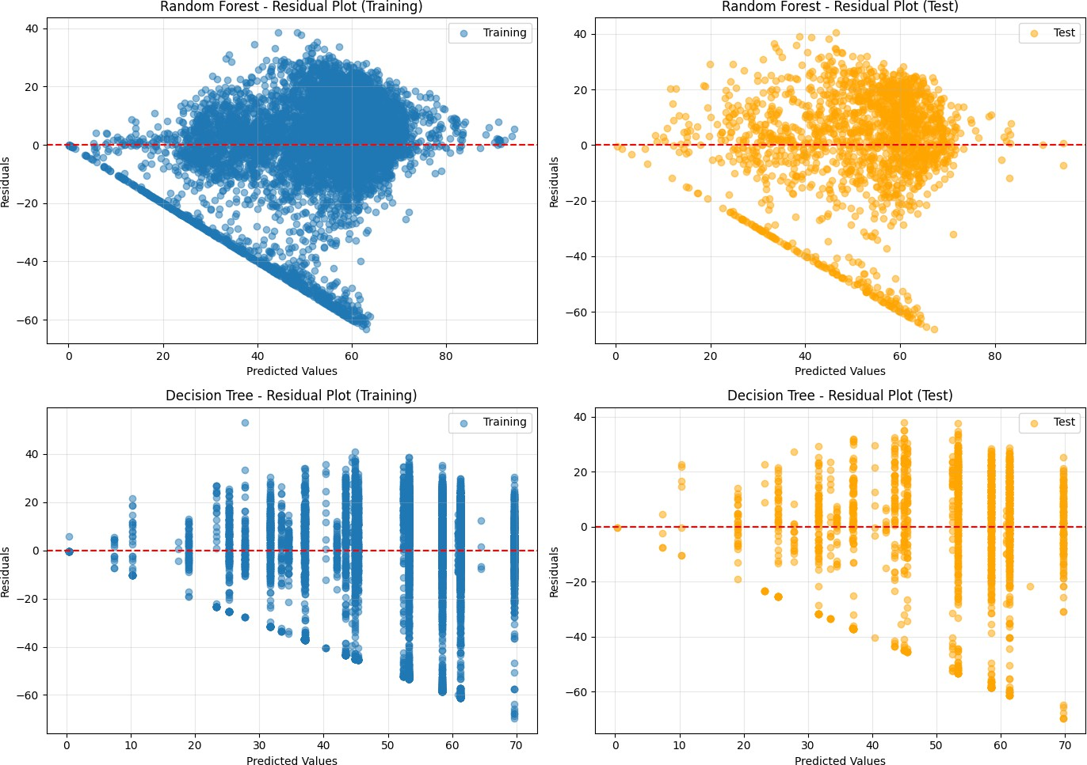

for idx, (name, model) in enumerate(models.items()): # Prediksi untuk training dan test

y_pred_train = model.predict(X_train) y_pred_test = model.predict(X_test)

# Residual

residuals_train = y_train - y_pred_train residuals_test = y_test - y_pred_test

# Plot residual training

axes[idx*2].scatter(y_pred_train, residuals_train, alpha=0.5, label='Training') axes[idx*2].axhline(y=0, color='r', linestyle='--')

axes[idx*2].set_xlabel('Predicted Values') axes[idx*2].set_ylabel('Residuals')

axes[idx*2].set_title(f'{name} - Residual Plot (Training)') axes[idx*2].legend()

axes[idx*2].grid(True, alpha=0.3)

# Plot residual test

axes[idx*2+1].scatter(y_pred_test, residuals_test, alpha=0.5, label='Test', color='orange') axes[idx*2+1].axhline(y=0, color='r', linestyle='--')

axes[idx*2+1].set_xlabel('Predicted Values') axes[idx*2+1].set_ylabel('Residuals')

axes[idx*2+1].set_title(f'{name} - Residual Plot (Test)') axes[idx*2+1].legend()

axes[idx*2+1].grid(True, alpha=0.3)

plt.tight_layout() plt.show()

Plot antara Fitur dan Target Untuk Setiap Model Pada Training Data

# Konversi X_train ke DataFrame



X_train_df = pd.DataFrame(X_train, columns=X.columns)

# Hitung korelasi dengan target

correlations = X_train_df.corrwith(pd.Series(y_train.values, index=X_train_df.index)).abs() top_4_features = correlations.nlargest(4).index.tolist()

print(f"4 fitur dengan korelasi tertinggi: {top_4_features}") fig, axes = plt.subplots(2, 2, figsize=(14, 10))

axes = axes.flatten()

for i, feat_name in enumerate(top_4_features):

# Scatter plot - AKSES dengan NAMA kolom, bukan indeks

axes[i].scatter(X_train_df[feat_name], y_train, alpha=0.5, label='Data')

# Tambahkan garis regresi

x_vals = X_train_df[feat_name]

# Regresi linear sederhana

coeffs = np.polyfit(x_vals, y_train, 1) poly = np.poly1d(coeffs)

x_range = np.linspace(x_vals.min(), x_vals.max(), 100)

axes[i].plot(x_range, poly(x_range), color='red', linewidth=2, label='Trend Line')

axes[i].set_xlabel(feat_name)

axes[i].set_ylabel('Target (Popularity)') axes[i].set_title(f'{feat_name} vs Target') axes[i].legend()

axes[i].grid(True, alpha=0.3)

plt.tight_layout() plt.show()

4 fitur dengan korelasi tertinggi: ['artist_popularity', 'artist_followers', 'album_type_single', 'explicit']

Prediksi vs Aktual

fig, axes = plt.subplots(1, 2, figsize=(14, 6)) # Ambil 20 sampel pertama

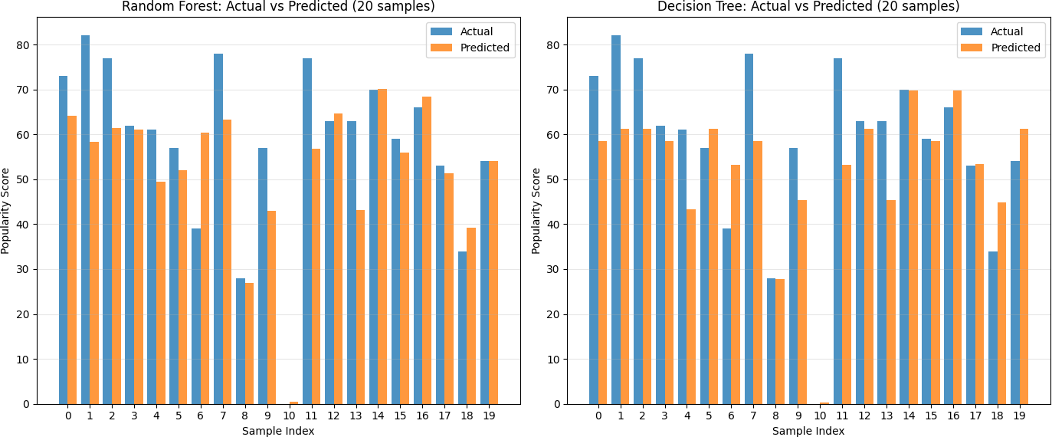

sample_indices = range(min(20, len(X_test)))

for idx, (name, model) in enumerate(models.items()): # Prediksi untuk 20 sampel pertama

X_sample = X_test.iloc[sample_indices] if hasattr(X_test, 'iloc') else X_test[sample_indices]

y_true_sample = y_test.iloc[sample_indices] if hasattr(y_test, 'iloc') else y_test[sample_indices] y_pred_sample = model.predict(X_sample)

# Buat dataframe untuk plotting df_compare = pd.DataFrame({

'Actual': y_true_sample,

'Predicted': y_pred_sample,

'Sample': list(sample_indices)

})

# Plot bar chart

x_pos = np.arange(len(df_compare))

axes[idx].bar(x_pos - 0.2, df_compare['Actual'], width=0.4, label='Actual', alpha=0.8)

axes[idx].bar(x_pos + 0.2, df_compare['Predicted'], width=0.4, label='Predicted', alpha=0.8)

axes[idx].set_xlabel('Sample Index')

axes[idx].set_ylabel('Popularity Score')

axes[idx].set_title(f'{name}: Actual vs Predicted (20 samples)') axes[idx].set_xticks(x_pos)

axes[idx].legend()

axes[idx].grid(True, alpha=0.3, axis='y')

plt.tight_layout() plt.show()

Mengambil Model Terbaik

best_rf_pipeline = grid_rf.best_estimator_ best_params = grid_rf.best_params_

best_cv_score = grid_rf.best_score_

# Prediksi pada Test Set

y_pred_best = best_rf_pipeline.predict(X_test) # Hitung Metrik Evaluasi Akhir

mse = mean_squared_error(y_test, y_pred_best) rmse = np.sqrt(mse)

mae = mean_absolute_error(y_test, y_pred_best) r2 = r2_score(y_test, y_pred_best)

print(f"Algoritma: Random Forest (dalam Pipeline)") print(f"Parameter Terbaik: {best_params}")

print(f"R2 Score (Cross-Validation Terbaik): {best_cv_score:.4f}") print("-" * 50)

print("Metrik Evaluasi pada TEST SET:") print(f"R-squared (R2): {r2:.4f}")

print(f"Root Mean Squared Error (RMSE): {rmse:.4f}") print(f"Mean Squared Error (MSE): {mse:.4f}")

print(f"Mean Absolute Error (MAE): {mae:.4f}")

Algoritma: Random Forest (dalam Pipeline)

Parameter Terbaik: {'feature_selection': None, 'model max_depth': 10, 'model min_samples_split': 5, 'model n_estimators': 200 R2 Score (Cross-Validation Terbaik): 0.3209

Metrik Evaluasi pada TEST SET: R-squared (R2): 0.3479

Root Mean Squared Error (RMSE): 19.6337

Mean Squared Error (MSE): 385.4812 Mean Absolute Error (MAE): 14.4914